**RRI Scan Software Overview**

1. **Software Entry**

The operation of the scan system is controlled through the vi named mastercontrol.vi. Mastercontrol is a portal to all components of data acquisition and motion control. The software is compiled in LabVIEW 2009. Run the software by pushing the right pointing arrow at the upper left corner of the window (Blue circle). Some settings will be configured based on location and some will be changed based on the scan mode.

Basic Motion of can be handled in the Green Box section. Click the buttons to open a motion interface, return to home, change global velocity or acceleration, or designate a scan overshoot (in mm). The Options Area (red box, may not have all options in figure based) sets up global values for special conditions.

Scan Modes (purple box) opens the actual scanning interface program Go. To end program execution, push exit.

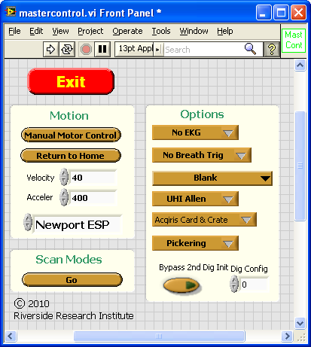

Rather than go into every operation in detail, make sure that the Show Context Help option under the Help tab is checked. Then, when a mouse is over a control, you will see text describing what the control does and any special considerations that are relevant. For the most part, the context help acts as the documentation.

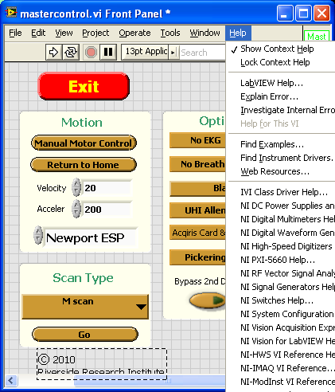

1. **Data Acquisition**

After pushing Go, you enter the data acquisition and display interface.

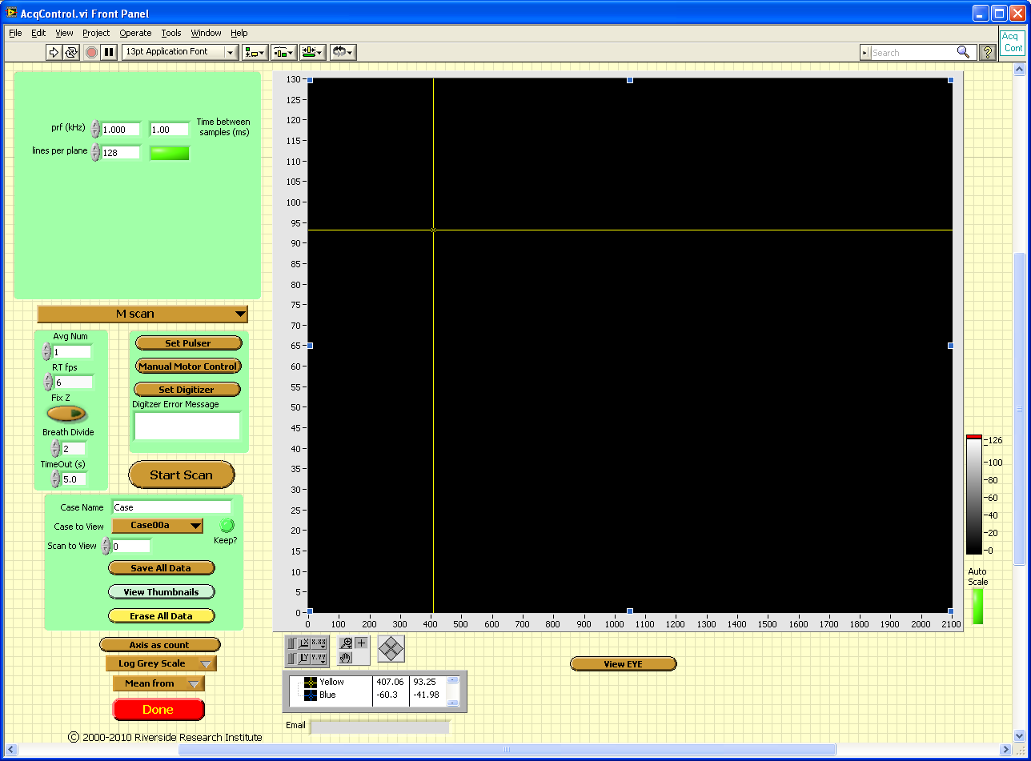

On the left, parameters related to scanning are entered. The parameters will dynamically adjust, based on the scan mode that is selected (brown oval pull down menu). Acquire data by pushing Start Scan (Red oval). Data is stored in a ~\TempBuff until it is saved or erased. Saved date gets saved in ~\Temp. In the lower right corner, there is a control to open the ViewEye.vi program. This reads the RRI style *.eye files. ViewEYE is also a stand-alone program.

The actual RF data is selected by pushing Set Digitizer (orange oval). This opens yet another window where an active RF trace is shown. This window acts more or less like an oscilloscope. The data that will be acquired is between the yellow and red lines in the live trace window.

Most of the information on inputs is visible in the Context Help window, but it is important to stress that the Sampling Rate represents the sampling rate for when you actually acquire data and not the sampling for the live trace. The live trace is sampled based on the Time Scale per Div setting.

The software can handle Acqiris hardware and NI-Scope based digitizers. The software dynamically adjusts to the resolution of the digitizer.

Data is saved in binary integer format with a 1024 header. See EyeHeader.xls for header fields. Labview and Matlab routines are available to work with the data.

1. **Cabling**

Cabling depends on location but typically involves some kind of box that switches programmatically between a fixed prf source, motion triggers, and gating or other trigger sources. In most cases, the Sync output of a function generator needs to be used and connected to the interface box. At this time, the software can only handle Agilent function generators and assumes a GPIB address of 11.

Cabling can vary based on configuration but typically has the trigger from the switch box triggering a pulser/receiver and digitizer. The RF output of the pulser goes to the digitizer also.

1. **Software**

Besides LabVIEW 2010 or the 2010 RunTimeEngine, the Measurement and Automation Explorer needs to be installed (Download latest version or use the NI Device Driver Install CD if you recently purchased something from NI). The NI components for NI-VISA, NI-Scope, NI-Motion and NI-Switch should be selected and installed during the install process. They are listed under NI Devices. In addition, Pickering Switch (pipx40vpp-31.exe), Acqiris 3.2a (8 and 12 bit drivers), and Tabor 1281A (WW1281_2_ww1281drv.exe) drivers need to be installed.

Also, if full LabVIEW package is used, need to place folders in C:\Program Files\National Instruments\LabVIEW 9\instr.lib for specific hardware. These folders are <hp33120a>, <ag33xxx>, and <Newport ESP301>.

Runtime apps will have an *.exe and support files.

1. **ESP Specific Notes**

The ESP velocity and acceleration are in mm units in software while all distances are in micrometers. This is some odd problem with the ESP that has to be lived with. If the unit beeps during operation, that means an error occurred. Some errors cause the motors to go in the off state. If this happens, turn them on using the ESP interface, or Exit mastercontrol and then run again with the right pointing arrow. (No need to completely close out of LabVIEW).

The ESP can handle GPIB or RS232 but the option is hard wired and cannot be changed on the fly.

The software currently is only hardwired to one Acqiris card. If two cards are in one machine, serial number addressing will be needed or the software always used the card that is detected first by the PCI bus.

Only X and Y axis exist for the ESP. Although additional axis are shown in the software, they will do nothing.

The ESP requires a small interface box that has a D-sub cable connecting to the ESP. It takes and input from the synch of a function generator (required) and an output that is the master trigger for all data acquisition. The software will switch between the function generator PRF and spatial triggers during motion.